# COSC3331 Human-Computer Interaction

# (Assignment 2)

**Assigned on Feb 14, 2017. Submit through blackboard by midnight Feb 28, 2017.**

**Question 1:** Given the following interface (20 points):

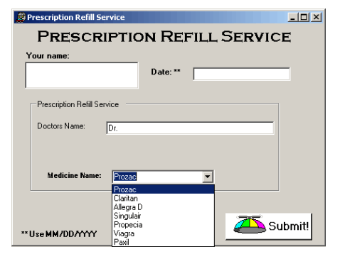

* Describe five things wrong with the above interface.
* Name two of the Eight Golden Rules that have been violated by this interface.

**Question 2:** For the same interface in Question 1, name two ways you could update the above interface to support the principles of direct manipulation. Implement an interface of your redesign (20 points).

**Question 3:** Examining the success of video games can provide insight for interface designers. Explain what lessons can be learned by video games for interface design, but also provide examples of areas where it is ineffective to do so (20 points).

**Question 4:** A telephone-based menu system is being designed for a magazine subscription service system. There are seven magazines available: National Geographic, Travel and Leisure, Entrepreneur, Time, Golf, US News and World Report, and Fortune. Describe three reasonable orderings of the voice menus and justify each (20 points).

**Question 5:** Design a touch screen music jukebox, which allows the user to select from a menu of the five most popular songs of the week. Design an interface for each of the following menu types: Binary Menu, Multiple-Item menu, Check boxes, Pull-down Menus. Argue which design serves the user best (20 points).

*Can put the menus all on one form.*